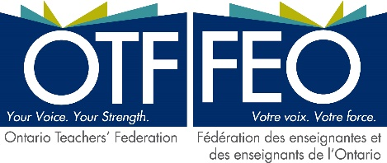

April 14, 2021

Sent by e-mail to: FColin@lufappul.org
Fabrice Colin
President
Laurentian University Faculty Association

Dear Fabrice Colin,

I am writing to you on behalf of the 160,000 teachers employed in the publicly funded schools of Ontario, who are members of the Ontario Teachers’ Federation (OTF). Teachers across Ontario were shocked and dismayed to learn of the decision taken by Lakehead University to close dozens of programs and to terminate some 100 faculty members at the institution. We want to let you know that we stand in solidarity with your members and that we support you in your fight to reverse this ill-conceived decision. OTF has a long-standing relationship with the Faculty of Education at Laurentian and we know how valuable both the Francophone and English-language teacher education programs have been, and continue to be, to students in the north and beyond.

You will find attached to this letter a news release that OTF issued earlier today to signal our objection to the decisions taken with regard to Laurentian University and urging the Ontario government to take steps to reverse these decisions.

If we can be of further assistance to you, I hope you will let us know.

Sincerely,

Parker Robinson
President, Ontario Teachers’ Federation

cc: Marie-Josée Berger, Provost, Laurentian University - mjberger@laurentian.ca
Rahul Sapra, President, Ontario Confederation of University Faculty Associations (OCUFA) - rsapra@ryerson.ca

PR/LA/ra

