2016 OCUFA SERVICE AWARD

CITATION FOR KATE LAWSON

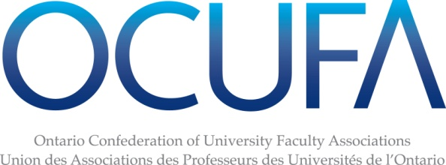
CITATION FOR KATE LAWSON

Read by Judy Bates, OCUFA President

The Ontario Confederation of University Faculty Associations is honoured to present Kate Lawson with a 2016 OCUFA Service Award. Whether providing steadfast leadership as President, or providing vital insight into policy areas like online learning, Kate has made an exceptional contribution to OCUFA’s ongoing work to protect the rights of faculty while ensuring higher education in Ontario remains high quality and accessible to all.

Kate’s list of roles in OCUFA is long and impressive. She served as a member-at-large on the OCUFA executive, and as Vice-President of the organization from 2011-2013. But her greatest contribution came as OCUFA’s President from 2013-15, guiding the organization through a series of challenges and opportunities. From continuing austerity in university funding to strategic mandate agreements and the differentiation agenda, Kate provided steady and visionary leadership. She was always available when called upon, and she represented the interests of faculty to media and government with skill and nuance. Even after two years of hectic presidential activity came to an end, Kate continues to serve OCUFA as chair of the Online Education Committee and chair of the Mandelbaum Graduate Fellowship selection committee.

Those who have worked with Kate recall her compassion, her fierce intelligence, and her tireless dedication to the rights of faculty. Her colleagues also highlight her good judgement and sensitivity to the needs of different constituencies within OCUFA’s membership. She is extraordinarily generous with her time, ready to make a valuable contribution when needed.

Kate’s nominator notes that she is not one to “blow her own horn” and seek accolades. She may not seek out awards, but we are thrilled to give her the recognition she so richly deserves. Kate, congratulations on your 2016 OCUFA Service Award.

